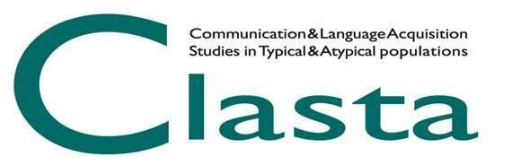

CLASTA AWARD 2024
BEST POSTER

CLASTA association announces the 2024 Best Poster Award. The best poster presented at the CLASTA 2024 Conference (May 17th-18th 2024) by a member of the association who is at the early steps of his/her professional career (e.g., Ph.D. student, post-doc or graduate fellow, graduate in training) will be awarded. CLASTA association reserves the right to communicate later the amount of the prize and any sponsors who will support the prize. CLASTA association could also award other works worthy of a Special Mention with prizes that will be communicated later.

Applications that meet the following requirements are accepted:
1) being a member of CLASTA association for the year 2024;
2) being registered at the CLASTA Conference;
3) being the first author of the poster;
4) presenting the poster in person at the CLASTA Conference;
5) having sent the abstract of the poster by April 7th 2024. For more details, please refer to the general submission guidelines.
6) having sent to giornateclasta@gmail.com the pdf file of the poster (70 x 100 cm, vertical orientation) by May 5th 2024, specifying in the subject “CLASTA 2024 Best Poster Award”.

Each CLASTA member can submit only one poster for the Best Poster Award. The same research (or different studies belonging to the same research) cannot simultaneously participate in Best Poster Award, Best Speech Therapist’s Thesis Award and/or the Young Researchers Symposium.

The Evaluation Committee will be composed of three members: one member of the CLASTA Board and two CLASTA members chosen by the CLASTA Board on the bases of their expertise in evaluating scientific works, paying attention in avoiding possible conflicts of interest (e.g., tutoring, co-authorship).

The evaluation of the submitted papers will be based on the following criteria:
1. Degree of theoretical and methodological innovation and originality of the research (0-5 points);
2. Methodological aspects of the research (0-5 points);
3. Evidence of clinical and practical implications (0-5 points);
4. Clarity in presentation and organization of contents / results (0-5 points).

The communication of the winner and the awarding ceremony will take place during the CLASTA Members Meeting, on May 17th 2024, within the CLASTA 2024 Conference.

