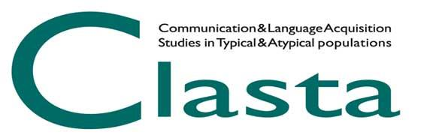
GIORNATE CLASTA – XIII EDITION

ABSTRACT SUBMISSION GUIDELINES
Abstracts for oral or poster contributions must be submitted online HERE by March 20, 2023.
Each participant may submit no more than two contributions and may appear as the first author in only one contribution. The first author must be duly registered at the Giornate CLASTA.
The title of the scientific contribution, the name and surname of each author, and the affiliation must be indicated in the abstract.
The abstract must not exceed 2.500 characters (including spaces) and should be structured in the following sections:
- Introduction: description of the issue and the aims of the study;
- Method: in case of empirical research, the description of participants, design (controlled factors and measured variables), and data analysis techniques must be presented; in case of a theoretical contribution or review, the type and extent of materials examined must be reported;
- Results: report of the main results, even if just preliminary (not expected results);
- Conclusions: theoretical and/or applicative implications of the results;
- References: (max 3 references).
Contributions on the presentation of new assessment techniques and/or treatment programs may also be submitted.
Abstracts, slides for oral presentations, and/or posters can be presented either in Italian or English.
After a peer-review process, accepted abstracts will be published on the www.clasta.org website.
A preference for an oral or poster presentation must be indicated on the abstract submission form. This will be considered by the Executive Committee in defining the program, as far as possible. Any changes related to the specified modality will be communicated to the corresponding author.
In the abstract submission form participants may also indicate the intention, or not, to participate in the Best Poster Award. If yes, participants have to send the poster before the 30th of April 2023 via email, writing to giornateclasta@gmail.com.
Once accepted, the participant (the first author) should finalize the subscription to the Giornate by paying the conference fee or joining CLASTA association.

REGISTRATION FEE

Payment of the registration fee for the Giornate or for joining CLASTA association should be carried out via bank transfer and payment receipt should be uploaded via the www.clasta.org website.
The registration fee includes access to all the conference sessions as well as to the abstracts and materials related to the conference that will be available for download on the www.clasta.org website.
The registration for the Giornate CLASTA is free of charge for members who are up-to date with their 2023 CLASTA membership fee: 60 euros (university staff, practitioners), 30 euros (undergraduate students, PhD students, postgraduates, graduates undergoing training).
The registration fee for the Giornate CLASTA for non-members is 60 euros (university staff, practitioners), 30 euros (undergraduate students, PhD students, postgraduates, graduates undergoing training).

