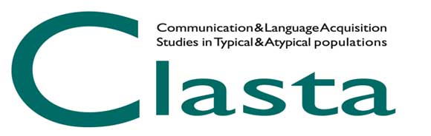

PREMIO CLASTA 2021
Best Poster Award

CLASTA association announces the 2021 edition of the Best Poster Award (Premio Miglior Poster). The best poster presented at the conference CLASTA 2021 (May 14th-15th 2021) by a member of the association, who is in the early steps of his/her professional career (e.g., Ph.D. student, post-doc or graduate fellow, graduate in training) will be awarded. A €300 cash prize, sponsored by Hogrefe publisher, will be awarded to the presenter of the winning poster. CLASTA association could also award other posters worthy of a Special Mention with prizes that will be communicated later.

Applications that meet the following requirements are accepted:
1) being a member of CLASTA association for the year 2021;
2) being registered at the CLASTA Conference;
3) being the first author of the poster;
4) presenting the poster in person at the CLASTA Conference;
5) having sent the abstract of the poster by April 19th 2021. For more details, see the abstract form;
6) having sent to giornateclasta@gmail.com the definitive pdf file of the poster (70 x 100 cm, vertical orientation) by May 9th 2021, specifying in the subject “Premio Miglior Poster 2021”.

Each CLASTA member can submit only one poster for the Best Poster Award. The same research (or different studies belonging to the same research) cannot simultaneously participate to both Best Poster Award and Best Speech Therapist’s Thesis Award.

The Evaluation Committee will be composed of three members: one member of the CLASTA Board and two CLASTA members chosen by the CLASTA Board, on the bases of their expertise in evaluating scientific works, paying attention in avoiding possible conflicts of interest (e.g., tutoring, co-authorship).

The evaluation of the works will be based on the following criteria:
1. Degree of theoretical and methodological innovation and originality of the research (0-5 points);
2. Methodological aspects of the research (0-5 points);
3. Evidence of clinical and practical implications (0-5 points);
4. Clarity in presentation and in organization of contents / results (0-5 points).

The communication of the winner and the awarding ceremony will take place during the CLASTA Members Meeting, on May 14th 2021, within the CLASTA 2021 Conference.

